Ex.No:7: CALCULATION AND VERIFICATION OF FREQUENCY DEVIATION AND MODULATION INDEX OF FM SIGNALS USING MATLAB SIMULATION
Objective 1:
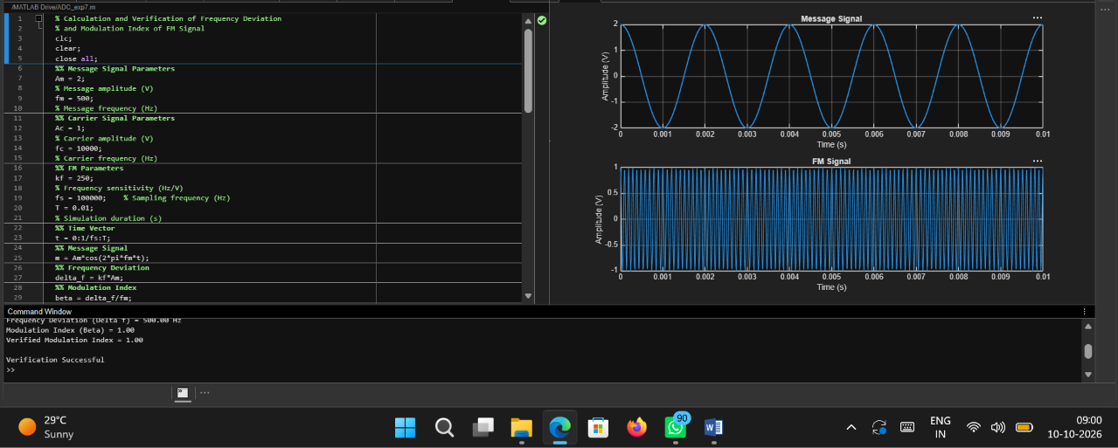
Code:
% Calculation and Verification of Frequency Deviation
% and Modulation Index of FM Signal
clc;
clear;
close all;
%% Message Signal Parameters
Am = 2;
% Message amplitude (V)
fm = 500;
% Message frequency (Hz)
%% Carrier Signal Parameters
Ac = 1;
% Carrier amplitude (V)
fc = 10000;
% Carrier frequency (Hz)
%% FM Parameters
kf = 250;
% Frequency sensitivity (Hz/V)
fs = 100000; % Sampling frequency (Hz)
T = 0.01;
% Simulation duration (s)
%% Time Vector
t = 0:1/fs:T;
%% Message Signal
m = Am*cos(2*pi*fm*t);
%% Frequency Deviation
delta_f = kf*Am;
%% Modulation Index
beta = delta_f/fm;
%% FM Signal
fm_signal = Ac*cos(2*pi*fc*t + beta*sin(2*pi*fm*t));
%% Display Parameters
fprintf('Carrier Frequency (fc) = %.0f Hz\n',fc);
fprintf('Message Frequency (fm) = %.0f Hz\n',fm);
fprintf('Message Amplitude (Am) = %.0f V\n',Am);
fprintf('Frequency Sensitivity (kf) = %.0f Hz/V\n',kf);
fprintf('\nFrequency Deviation (Delta f) = %.2f Hz\n',delta_f);
fprintf('Modulation Index (Beta) = %.2f\n',beta);
%% Verification
beta_verify = delta_f/fm;
fprintf('Verified Modulation Index = %.2f\n',beta_verify);
%% Verification Check
tolerance = 1e-6;
if abs(beta - beta_verify) < tolerance
fprintf('\nVerification Successful\n');
else
fprintf('\nVerification Failed\n');
end
%% Plotting
figure;
subplot(2,1,1);
plot(t,m,'LineWidth',1.5);
grid on;
title('Message Signal');
xlabel('Time (s)');
ylabel('Amplitude (V)');
subplot(2,1,2);
plot(t,fm_signal,'LineWidth',1);
grid on;
title('FM Signal');
xlabel('Time (s)');
ylabel('Amplitude (V)');
Output:
